CS 5531 Advanced Software Engineering

Lab 4

**SOAP Service:**

The source code of the project is uploaded in the github link.

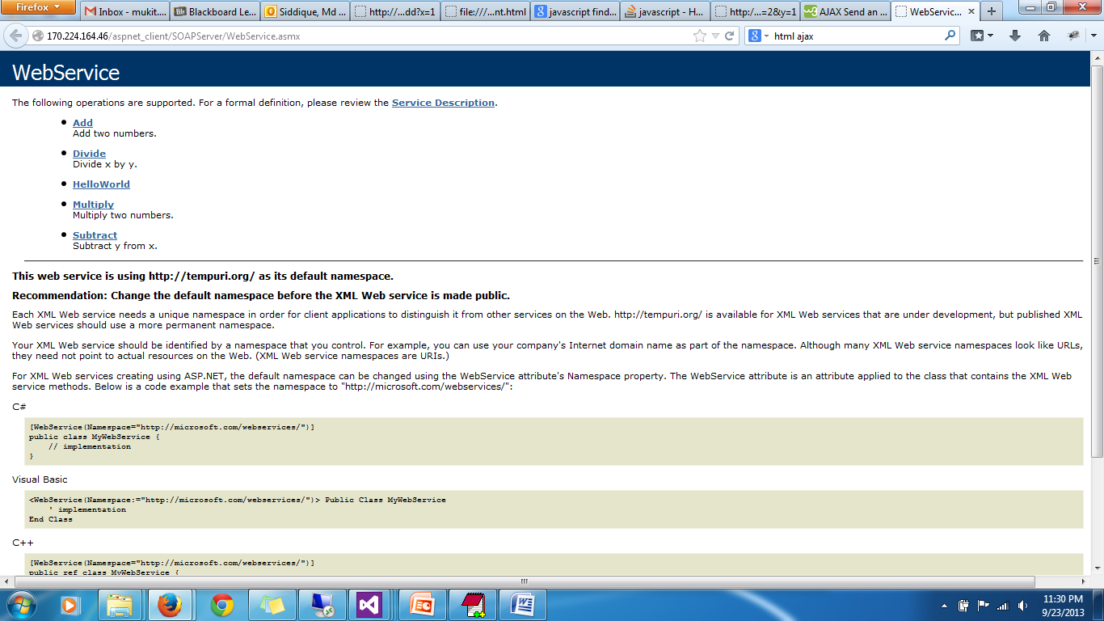

Figure 1: The SOAP services from remote server

**REST Service:**

The source code of the project is uploaded in the github link.

**The Request Format:**

[host-url]/[path-to-service]/[service-name]?[param1]&[param2]

**The Response Format (JSON):**

{ErrorMessage:<value>, opName:<value>, result:<value>, x:<param1>, y:<param2>}

|  |  |
| --- | --- |
| Sample Request | Sample Response |
| http:// vhost1066.site1.compute.ihost.com /aspnet_client/WcfService3/Service1.svc/**add?x=1&y=2** | {"ErrorMessage":"","OpName":"addition","result":3,"x":1,"y":2} |

**SOAP Client:**

The client is implemented as a web application using SOAP service as a “web reference”. The source code is provided in github.

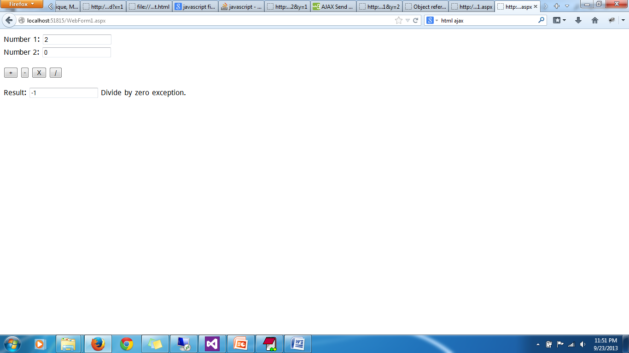

Figure 2: Sample Client

**REST Client:**

The client is implemented as a web page accessing REST service through AJAX call.

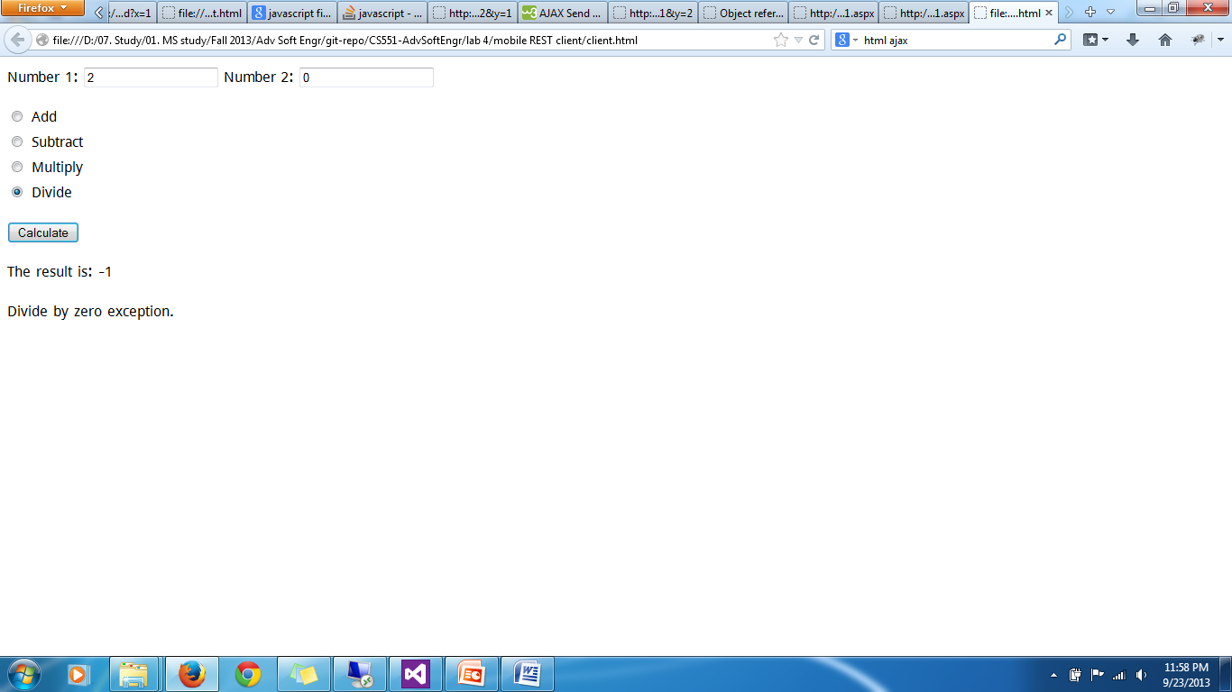

Figure 3: Sample REST client